**Orphaned volume check**

**Need to do on all 5 Accounts.**

155484157719 (atos-aws-p11-ra01-p)Production

904275948294 (atos-aws-p11-ra02-p)Core Services

363108362589 (atos-aws-p11-ra01-np)NonProd

975226774250 (atos-aws-p11-ra02-np)Sandbox

835635460036 (atos-aws-p11-ba01-p)ICE DR

**Login to AWS account.**

**Step 1 :** Search for EC2 in the search box and click on it.

**Step 2:**  Go to the volume

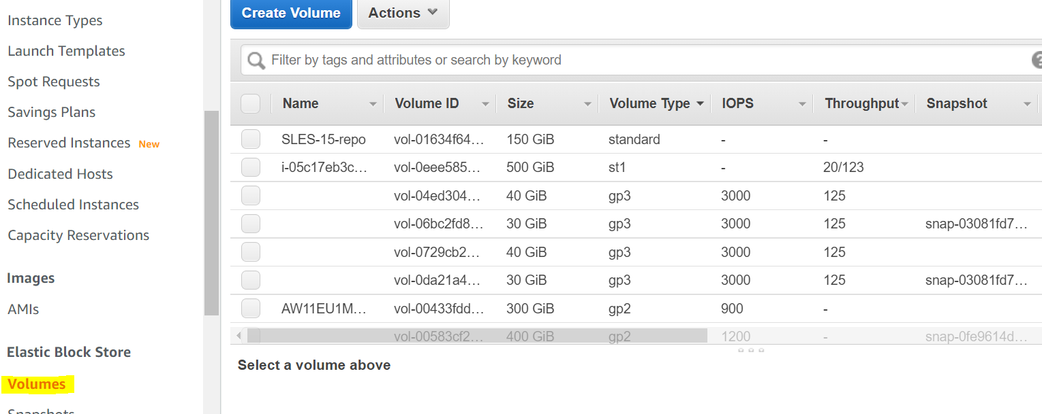

**Step 3:**

In the Filter search for state: Available

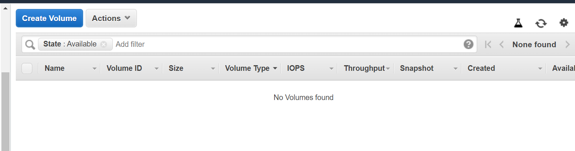

Make sure there is no volumes in available state. If there any volumes available report it to the team and investigate.

**Step 4:** Repeat this steps for all the 5 accounts.